### CMR INSTITUTE OF TECHNOLOGY

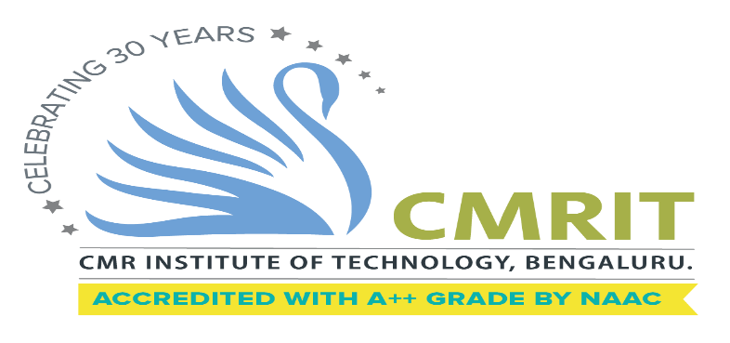

**DEPARTMENT OF INFORMATION SCIENCE & ENGINEERING**

**Declaration**

We, **Adithyan R (1CR19IS008), C Tarun Teja (1CR19IS023), Chiragraju S (1CR19IS029),** bonafide students of **CMR Institute of Technology**, Bangalore, hereby declare that the dissertation entitled, **“Patient Readmission Prediction Based On Explainable AI''** has been carried out by us under the guidance of **Prof. Sugunadevi C**, Designation, CMRIT, Bangalore, in partial fulfilment of the requirements for the award of the degree of Bachelor of Engineering in Information Science & Engineering, of the Visvesvaraya Technological University, Belgaum during the academic year 2022-2023. The work done in this dissertation report is original and it has not been submitted for any other degree in any university.

Adithyan R (1CR19IS008)

C Tarun Teja (1CR19IS023)

Chiragraju S (1CR19IS029)

**Acknowledgement**

The satisfaction and euphoria that accompany a successful completion of any task would be incomplete without the mention of people who made it possible. Success is the epitome of hard work and perseverance, but steadfast of all is encouraging guidance.

So, it is with gratitude that we acknowledge all those whose guidance and encouragement served as beacon of light and crowned our effort with success.

We would like to thank Dr. Sanjay Jain, Principal, CMRIT, Bangalore, for providing an excellent academic environment in the college and his never-ending support for the B.E program.

We would like to express our gratitude towards Dr. Farida Begam, Professor and HOD, Department of Information Science & Engineering CMRIT, Bangalore, who provided guidance and gave valuable suggestions regarding the project.

We consider it a privilege and honour to express our sincere gratitude to our internal guide Prof. Sugunadevi C, Assistant Professor, Department of Information Science & Engineering, CMRIT, Bangalore, for their valuable guidance throughout the tenure of this project work.

We would like to thank all the faculty members who have always been very cooperative and generous. Conclusively, we also thank all the non- teaching staff and all others who have done immense help directly or in- directly during our project.

Adithyan R (1CR19IS008)

C Tarun Teja (1CR19IS023)

Chiragraju S (1CR19IS029)